7 SEGMENT DISPLAY

AIM : To perform 7 segment display on the breadboard.

COMPONENTS :

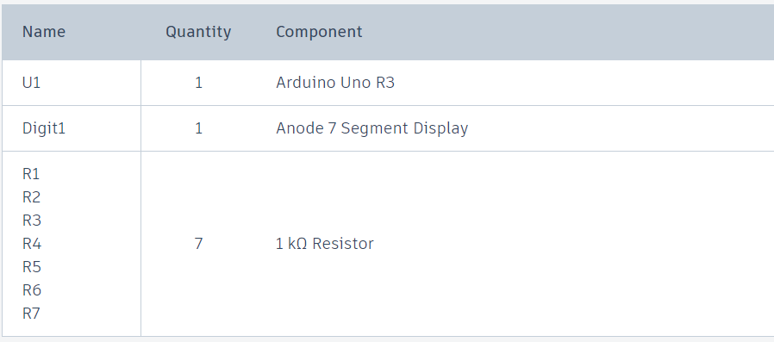

PROCEDURE :

Step 1: Identify the Pin Configuration.

* **Pin Identification:** Look at the datasheet for your specific 7-segment display to identify the pins. A typical 7-segment display has 10 pins. The segments (a to g and sometimes a dot) are labelled , and there is a common pin (either cathode or anode).

Step 2: Place the Display on the Breadboard

* Insert the 7-segment display into the breadboard, ensuring each pin has its own row for easy connection.

Step 3: Connect the Common Pin

* **Common Cathode Display:**
  + Connect the common cathode pin(s) to the ground (GND) rail on the breadboard.
* **Common Anode Display:**
  + Connect the common anode pin(s) to the 5V rail on the breadboard

**Step 4: Connect Resistors**

1. Place a resistor (220Ω to 1kΩ) between each segment pin (a to g) and the corresponding Arduino digital I/O pin. This limits the current through each segment to prevent damage.

SCHEMATIC CIRCUIT DIAGRAM :

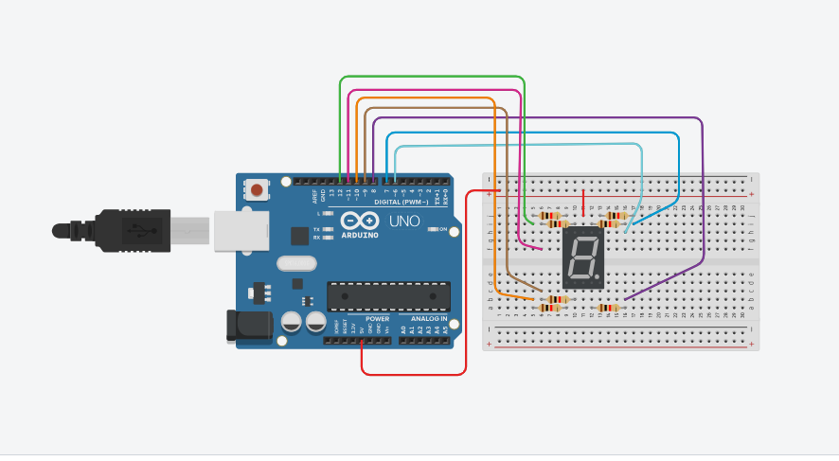

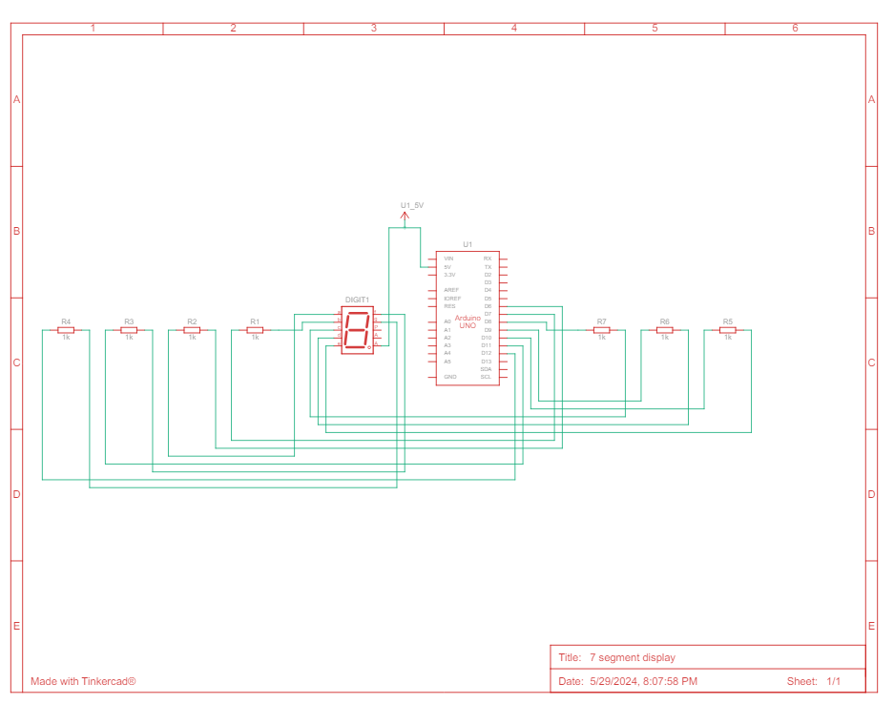

RESULT : Setting up and programming a 7-segment display with an Arduino is a straightforward and rewarding project that enhances your understanding of both hardware and software integration. By following the procedure, you learned how to identify and connect the pins of a 7-segment display, utilize current-limiting resistors to protect the LEDs, and write an Arduino program to control the display.

Tammali Karthik- BU21EECE0100164

Maria Punya – BU21EECE0100309

Alli Gopi – BU21EECE0100161